Understanding Regex

Source : Mastering Regular Expressions Third Edition by Jeffrey E. F. Friedl

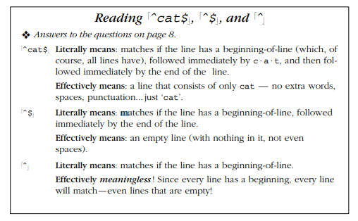

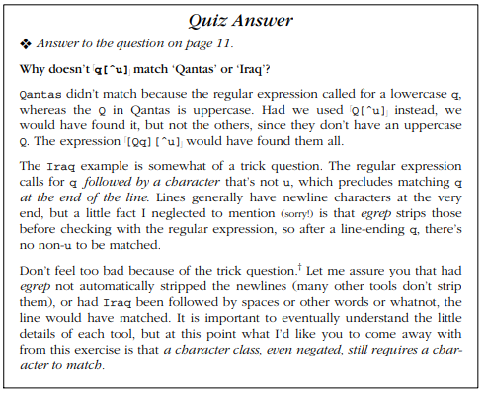

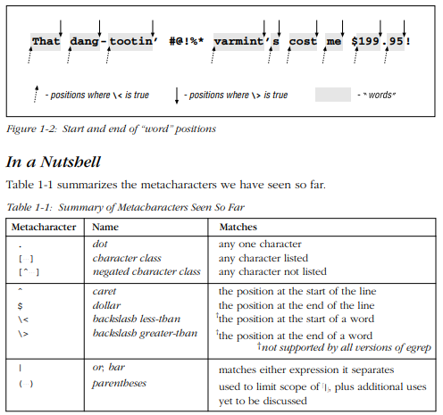

In addition to the table, important points to remember include: • The rules about which characters are and aren’t metacharacters (and exactly what they mean) are dif ferent inside a character class. For example, dot is a metacharacter outside of a class, but not within one. Conversely, a dash is a metacharacter within a class (usually), but not outside. Moreover,acar et has one meaning outside, another if specified inside a class immediately after the opening [, and a third if given elsewhere in the class. • Don’t confuse alternation with a character class. The class ![abc]" and the alternation !(a;b;c)" ef fectively mean the same thing, but the similarity in this example does not extend to the general case. A character class can match exactly one character, and that’s true no matter how long or short the speci- fied list of acceptable characters might be.

Alter nation, on the other hand, can have arbitrarily long alternatives, each textually unrelated to the other: !\". However, alter nation can’t be negated like a character class. • A negated character class is simply a notational convenience for a normal character class that matches everything not listed. Thus, ![ˆx]" doesn’t mean “ match unless there is an x ,” but rather “ match if there is something that is not x .” The differ ence is subtle, but important. The first concept matches a blank line, for example, while ![ˆx]" does not. • The useful -i option discounts capitalization during a match (☞ 15).†

